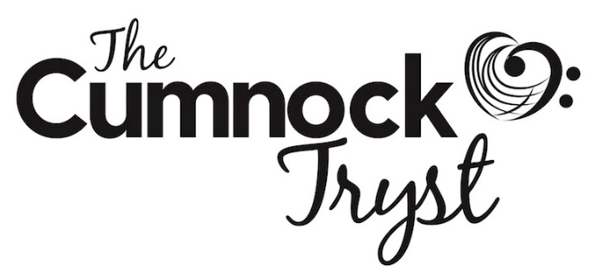

Volunteering
We aim to give our volunteers a fun and rewarding experience, working with the Tryst team as the face of the festival, helping our artists and audiences have the best experience possible.
If you are interested in joining the team please fill in this form or get in touch - supportus@thecumnocktryst.com.
Name:
Email:
Tel:
Please tick the areas of work you are interested in:
Front of house: may include working as an usher, taking tickets, selling refreshments, selling programmes, directing audience to their seats
Driving artists (must have relevant insurance for your car – can be arranged easily with car insurers)
Box office (ideally with some experience of working with money)
Marketing: may include leafleting, delivering brochures, attending events

Please tick the sessions you are available for (ideally please tick at least 3 sessions throughout the festival weekend):
Thurs 3 Oct eve (18.00-23.00)
Not everyone required for late night slot
Fri 4 Oct pm (11.30-18.00)
Fri 4 Oct eve (18.00-23.00)
Not everyone required for late night slot
Sat 5 Oct am (10.00-12.30)
Sat 5 Oct pm (15.00-18.00)
Sat 5 Oct eve (18.00-23.00)
Not everyone required for late night slot
Sun 6 Oct am (10.00-13.00)
Sun 6 Oct pm (12.30-18.00)
Sun 6 Oct eve (18.00-21.30)

We look forward to welcoming you as a 2019 Tryst volunteer.

