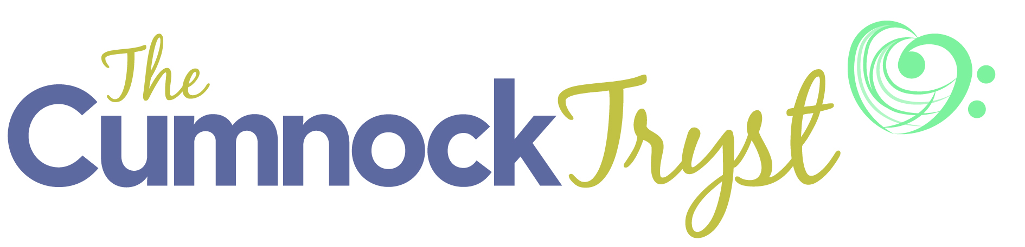
News Release (embargoed until 00.01 on Wednesday 17 June 2015)
Programme for 2015 Cumnock Tryst announced
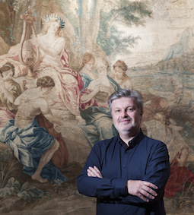
The Cumnock Tryst Founder and Artistic Director, Sir James MacMillan, in Dumfries House
where some of the 2015 Festival events will take place

- Inaugural concert for The Cumnock Tryst Festival Chorus with soloists from
Genesis Sixteen
- Hebrides Ensemble are Artists in Residence
- Composition and song-writing summer school
- Three year collaboration with Drake Music Scotland announced
- Performances by The King’s Singers, two recent BBC Young Musician of the Year winners, the Whistlebinkies and more
- The Cumnock Hour with Drake Music Scotland’s Thursa Sanderson; folk musician, Jo Mango; and broadcaster Muriel Gray
- World Premieres: new work by Sir James MacMillan and festival commission from Jay Capperauld

Sir James MacMillan, who received a knighthood for services to music in the 2015 Queen’s Birthday Honours, unveiled the programme for the 2015 Cumnock Tryst at a special event in the East Ayrshire town this evening, 16 June 2015. Established by the internationally acclaimed composer in his home town, The Cumnock Tryst is a celebration of music making at its very best. The 2015 Festival will see a rich and varied programme staged in venues across the town and in Dumfries House over the weekend of 1-4 October.

Commenting on the knighthood MacMillan said: “I am totally delighted to receive this honour. I am especially pleased that the world of music, and contemporary composition in particular, will receive greater focus and recognition as a result. I feel encouraged and re-energised in my commitments in these fields and especially in my work with The Cumnock Tryst."

“After the wonderful experience of the inaugural festival last year I have been very excited about following up with a new set of concerts and events,” says MacMillan. “Threads continuing in this year’s festival include our exploration of brass music, which is so integral to the musical history of the area, and choral music.”

“I am delighted to announce that the 2015 Festival will see the first concert by The Cumnock Tryst Festival Chorus. Working with Eamonn Dougan, under whose direction the Come and Sing Day last year was such a huge success, the chorus will be joined by members of Genesis Sixteen and our festival Artists in Residence, The Hebrides Ensemble, for a programme that includes the Fauré Requiem.”

The Cumnock Tryst Patron, Nicola Benedetti with the pupils of Greenmill Primary School.
Pupils from the school performed at the 2015 festival launch and will take part in the schools workshops

Children and young people continue to be a key focus of the Cumnock Tryst. This year two winners of the BBC Young Musician of the year - pianist Martin James Bartlett and cellist Laura van der Heijden will give recitals. Meanwhile, Jay Capperauld, from New Cumnock - one of the best of recent graduate composers from the Royal Conservatoire of Scotland - returns with a brand new commission. Over the summer MacMillan will also work with school groups on a number of composing workshops and, it was announced, the Festival has formed a partnership with Drake Music Scotland.

“Drake Music Scotland are leaders in music, disability and technology,” says MacMillan. “We welcome them to The Cumnock Tryst this year at the beginning of an exciting three year partnership. We are looking forward to working together with children with additional support needs and with other young people who will present their music to the festival audience in a special concert.”

The 2015 Festival opens on Thursday 1 October with a concert by the Whitburn Band in the newly refurbished Cumnock Town Hall, which includes a performance of MacMillan’s Canite Tuba conducted by the composer.

Friday’s events begin with a special concert at Cumnock Academy which will be the result of a week of intense composition and song writing lessons, and workshops for Higher and Advanced Higher music students from East Ayrshire schools with James MacMillan, songwriters Jo Mango and David Scott, and musicians from the Hebrides Ensemble. It will also feature performances resulting from a collaboration between The Cumnock Tryst and Drake Music Scotland, and children from Hillside School and Barshare Primary School.

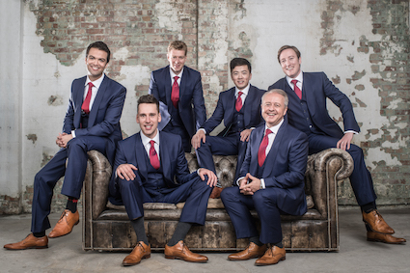
Acclaimed a capella group, The King’s Singers

Later in the afternoon director of Drake Music Scotland, Thursa Sanderson, Jo Mango and broadcaster Muriel Gray join with MacMillan for The Cumnock Hour in the Dumfries Arms. The evening concert brings one of the world’s most acclaimed a capella groups, The King’s Singers, to Cumnock. The group will perform a broad programme ranging from Medieval and Baroque to contemporary works including MacMillan’s A Rumoured Seed and Steve Martland’s Oranges and Lemons.

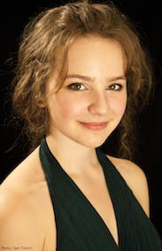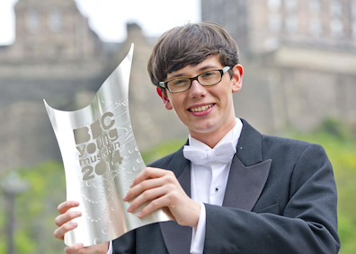
‘celllst Laura van der Heijden and pianist Martin James Bartlett, the two most recent
winners of the BBC Young Musician of the Year competition

Saturday’s programme begins with recitals in St John’s Church by the two most recent winners of the BBC Young Musician of the Year competition. The first performance will see pianist Martin James Bartlett play music by Scarlatti, Beethoven, Chopin and Prokofiev. This is followed by cellist Laura van der Heijden whose programme includes works by Schnittke, Rachmaninov and MacMillan, and the World Premiere of a new festival commission from Jay Capperauld. The evening sees the inaugural concert by the Cumnock Festival Chorus in Cumnock Old Church. Conducted by Eamonn Dougan, the Festival Chorus will be joined by members of Genesis Sixteen, the Hebrides Ensemble and NYOS Camerata. Together they will perform Bach’s Partita in D minor with chorales, the World Premiere of new work by James MacMillan and the glorious Fauré Requiem. The day’s events conclude with a late night performance by the Whistlebinkies with local poet Rab Wilson at the Dumfries Arms.

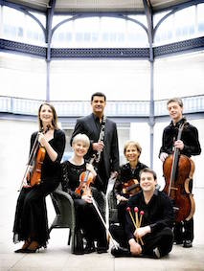
The Hebrides Ensemble, Artists in Residence at the 2015 Cumnock Tryst

The Sunday Festival Service will take place in Trinity Church this year with music by the University of Strathclyde Chamber Choir, and conductor / organist Alan Tavener. The Festival Finale will then take place in the glorious setting of Dumfries House. There will be two performances of a trio of recitals. Harpist Gabriella Dall’Olio performs the World Premiere of a new work by James MacMillan alongside pieces by Donatoni and Fauré in the Tapestry Room; Horn-player, Alec Frank-Gemmill performs works by Aho and MacMillan in the entrance hall; and a trio from the Hebrides Ensemble play works by the contemporary Hungarian composer Kurtág and by Bach (arr. Mozart) in the Great Steward’s Dining Room.

The popular Festival Club at the Dumfries Arms returns with performances this year by pianist Fergus McCreadie - twice winner of the Young Scottish Jazz Musician Award for under 17s and finalist in this year’s Young Scottish Jazz Musician of the year, together with David Bowden (bass) and Stephen Henderson (drums) on the Thursday night, and the celebrated Damellington Band on the Friday night.

Tickets for the Cumnock Tryst 2015 concerts available:
By telephone on 01563 554 900;
In person at Cumnock Town Hall, 62 Glaisnock Street and Palace Theatre, Kilmarnock
Online via thecumnocktryst.com
(Transactions are subject to Box Office booking fees).

The Cumnock Tryst is made possible with support from Roberta and Howard Ahmanson, Genesis Foundation, William Grant Foundation, Cumnock and Doon Valley Minerals Trust, East Ayrshire Council and The Great Steward of Scotland’s Dumfries House Trust as well as Festival Patrons and Friends

For further information on The Cumnock Tryst visit: www.thecumnocktryst.com
Follow the festival on Facebook and on Twitter @TheCumnockTryst

Ends

Further information, interviews and images
Lesley Booth 0779 941 4474 lesley@newcenturypr.com

Notes for Editors
The Cumnock Tryst was founded by composer Sir James MacMillan in 2014. The Festival’s name, The Cumnock Tryst, was inspired by a piece of music James MacMillan wrote in the 1980s when he was still living in Ayrshire. This was a setting of William Soutar’s love poem, The Tryst. Tryst is an old Scots word which means a meeting place, or a romantic rendezvous. The town of Cumnock itself ties into this sense of coming together as its Gaelic name, comunn achadh, means place of the confluence, as the town sits where the Glaisnock River and the Lugar Water meet. For four packed days and nights The Cumnock Tryst is a meeting place for music-lovers.

Sir James MacMillan biography
One of Britain’s most successful living composers, Sir James MacMillan is renowned for his powerful scores which are rich with dramatic gestures, moments of lyrical beauty and spirituality. His music is performed by the world’s leading orchestras including the London Symphony Orchestra, New York Philharmonic and many others. He was awarded a CBE in January 2004 and a knighthood in June 2015.

In addition to The Confession of Isobel Gowdie, which launched MacMillan's international career at the BBC Proms in 1990, his orchestral output includes his first percussion concerto Veni, Veni, Emmanuel, premiered by Evelyn Glennie in 1992 and which has since received close to 500 performances worldwide.

Works by MacMillan also include Seven Last Words from the Cross for chorus and string orchestra, a triptych of orchestral works commissioned by the London Symphony Orchestra: The World's Ransoming, a Cello Concerto for Mstislav Rostropovich, and Symphony: 'Vigil' premiered under the baton of Rostropovich in 1997, and Quickening for The Hilliard Ensemble, chorus and orchestra, co-commissioned by the BBC Proms and the Philadelphia Orchestra. His Symphony No 4 will be premiered at the BBC Proms in August 2005, by Donald Runnicles and the BBC Scottish Symphony Orchestra.

His St John Passion, co-commissioned by the LSO, Royal Concertgebouw Orchestra, Boston Symphony Orchestra and Berlin Radio Choir, was premiered under the baton of Sir Colin Davis in 2008. The past five years have brought a successful sequence of concertos: for violinist Vadim Repin, pianist Jean-Yves Thibaudet (his third piano concerto), oboist Nicholas Daniel, violist Lawrence Power and percussionist Colin Currie (his second percussion concerto). Orchestral scores have included Woman of the Apocalypse premiered by Marin Alsop at the Cabrillo Festival and performed by the São Paulo Symphony in 2014. Works with choir include a new setting of the St Luke Passion for chorus and chamber orchestra. His one-act chamber opera Clemency has been performed in London, Edinburgh and Boston. 2014 saw MacMillan launching a new music festival in his home town of Cumnock.

Internationally active as a conductor, MacMillan has earned praise for his clear and focused presence and the composer’s insight he brings each score. James MacMillan was Composer-Conductor of the BBC Philharmonic from 2000- 2013. He was Principal Guest Conductor of the Netherlands Radio Chamber Philharmonic from 2010 – 2014. In Spring 2014 Macmillan conducted three projects with the BBC Scottish Symphony Orchestra including the orchestra’s first tour to India. Highlights of the current season include a new production of his 1990 opera Ines de Castro with Scottish Opera, Composer in Residence with the Sao Paulo Symphony where he conducted a choral programme, return conducting engagements with the Royal Liverpool Philharmonic, City of Birmingham Symphony Orchestra, Britten Sinfonia and debuts with Bergen Philharmonic among others. In recent seasons he has conducted orchestras such as the London Symphony Orchestra, NHK Symphony Orchestra, Danish National Symphony, Baltimore Symphony and New Zealand Symphony.

Listings

Thursday 1 October at 7.30pm
Cumnock Town Hall, 62 Glaisnock Street, Cumnock, KA18 1BY
Whitburn Band
18 time winners of the Scottish Championships, the celebrated Whitburn Band opens the 2015 Cumnock Tryst with a programme that includes James MacMillan’s Canite Tuba conducted by the composer.
Tickets priced £16 / £10 for under 26s and local residents
www.thecumnocktryst.com

Thursday 1 October 2015 at 9.30pm
Festival Club
Dumfries Arms, 54 Glaisnock Street, Cumnock, KA18 1BY
Jazz night with the talented young musicians of The Fergus McCreadie Trio.
Free
www.thecumnocktryst.com

Friday 2 Oct at 12.30pm
Songs and Compositions
Cumnock Academy, School Hall, Ayr Road, Cumnock, KA18 1EH
Hebrides Ensemble, Drake Music, James MacMillan, Jo Mango, David Scott and up to 10 young composers and songwriters
Performance of pieces written as part of this summer’s song writing and composition courses,
and a Drake Music Scotland / Hebrides Ensemble collaborative workshops in local primary schools.
Free
www.thecumnocktryst.com

Friday 2 October at 5pm
Dumfries Arms, 54 Glaisnock Street, Cumnock, KA18 1BY
The Cumnock Hour
James MacMillan is joined by director of Drake Music Scotland, Thursa Sanderson, and Folk musician, Jo Mango. Event chaired by broadcaster and author, Muriel Gray.
Tickets: £5
www.thecumnocktryst.com

Friday 2 October at 7.30pm
Trinity Church, 46 Ayr Road, Cumnock, KA18 1DW
The King’s Singers
One of the world’s most celebrated a capella groups performs works ranging from the Medieval and Baroque to contemporary pieces by MacMillan and Martland.
Tickets: £25 / £15 for under 26s and local residents
www.thecumnocktryst.com

Friday 2 October 2015 at 9.30pm
Festival Club
Dumfries Arms, 54 Glaisnock Street, Cumnock, KA18 1BY
Round off the day with the musicians of the Dalmellington Band in relaxed mode.
Free
www.thecumnocktryst.com

Saturday 3 October at 11.30am
St John’s Church, 92 Glaisnock Street, Cumnock, KA18 1JU
BBC Young Musician of the Year winner: Martin James Bartlett
Winner of the 2014 Young Musician of the Year competition, pianist Martin James Bartlett, plays a programme of works by Scarlatti, Beethoven, Prokofiev and Chopin.
Tickets: £16 / £10 for under 26s and local residents
OFFER: Buy a ticket for one Young Musicians recital and get one for the other recital half price
www.thecumnocktryst.com

Saturday 3 October at 4pm
St John’s Church, 92 Glaisnock Street, Cumnock, KA18 1JU
BBC Young Musician of the Year winner: Laura van Heijden
Winner of the 2012 Young Musician of the Year competition Laura van der Heijden, plays works for cello including James MacMillan’s Kiss on Wood and the World Premiere of a new commission from Jay Capperauld.
Tickets: £16 / £10 for under 26s and local residents
OFFER: Buy a ticket for one Young Musicians recital and get one for the other recital half price
www.thecumnocktryst.com

Saturday 3 October at 7.30pm
Old Church, The Square, Cumnock, KA18 1DB
Festival Chorus Inaugural Concert
Hebrides Ensemble, NYOS Camerata, the Cumnock Tryst Festival Chorus, Genesis Sixteen
Andrew McTaggart, choir master, Eamonn Dougan, conductor
The Cumnock Tryst Festival Chorus gives its inaugural performance in a concert that includes the World Premiere of a new work by James MacMillan and the glorious Fauré Requiem with soloists from the talented young singers of Harry Christophers’ Genesis Sixteen.
Tickets: £16 / £10 for under 26s and local residents
FAMILY OFFER: £4 for children (age 16 and under)
www.thecumnocktryst.com

Saturday 3 October at 9.30pm
The Whistlebinkies with Rab Wilson and Friends
Dumfries Arms Hotel, 54 Glaisnock Street, KA18 1BY
Scottish traditional music band, The Whistlebinkies, are joined in a late night concert by Scots poet and playwright Rab Wilson. Audience invited to bring and read their own short poems.
Tickets: £10 / £6 for under 26s and local residents
www.thecumnocktryst.com

Sunday 4 October, 5pm and 7.30pm
Festival Finale: Promenade Concerts
Dumfries House: Tapestry Room, Entrance Hall and The Great Steward’s Dining Room
Gabriella dall’Olio, harp; Alec Frank-Gemmill Solo horn and a trio from the Hebrides Ensemble
Two performances of a trio of recitals in the glorious setting of Dumfries House. Music ranges from Bach and Faure to Kurtág, Maxwell Davies and MacMillan.
Tickets: £25 / £15 for under 26s and local residents.
For the 7.30pm performance, followed by post-concert reception, £50 / £40 for under 26s and local residents.
www.thecumnocktryst.com

